




Business Intelligence and Data Summarisation Using AI Prompts

Project Domain
Excel or Power BI with Chatbot
A Project Report
submitted in partial fulfilment of the requirements of the AICW Project

by:



Student Name
Jeeva T
Student Email
jeevathangaraj9@gmail.com
Guide
Bharathi Raja

Institution:
AIMAN College of Arts And Science For Women

Year - 2026
ACKNOWLEDGEMENT
I take this opportunity to express my profound gratitude to all those who have supported and guided me throughout the successful completion of this project.
I would like to sincerely thank my project guide Umamaheshwari, for their invaluable guidance, continuous encouragement, and insightful suggestions. Their expertise and constructive feedback played a crucial role in shaping this project and enhancing its quality. Their constant support and motivation were instrumental in overcoming challenges during the course of this work.

I would also like to extend my heartfelt thanks to the Edunet Foundation, in collaboration with Microsoft, LinkedIn, and SAP, for providing me with the opportunity to be a part of the AICW Fellowship Program. The learning resources, mentorship, and exposure to modern AI and data analytics tools significantly contributed to my academic and professional development.

I am equally grateful to my institution, AIMAN College of Arts And Science for Women, for providing the necessary infrastructure, resources, and a supportive environment that enabled me to complete this project efficiently.
Finally, I express my sincere thanks to my family and friends for their unwavering support, encouragement, and understanding, which kept me motivated throughout the project journey.

ABSTRACT OF THE PROJECT
This project is part of the AICW (Artificial Intelligence in the Contemporary World) Fellowship Program, a collaborative initiative by Edunet Foundation in partnership with Microsoft, LinkedIn, and SAP. The fellowship aims to equip students with practical skills in Artificial Intelligence, Data Analytics, and Business Intelligence tools.

The primary objective of this project is to analyze financial and economic data to understand the relationship between macroeconomic indicators and market performance. The dataset used in this project includes variables such as GDP growth, inflation rate, unemployment rate, interest rates, stock market index values, and commodity prices. The major problem identified was the presence of unstructured and inconsistent data, which made analysis difficult and time-consuming.

To address this issue, data cleaning and preprocessing techniques were applied using Microsoft Excel. This included removing duplicate entries, handling missing values, and standardizing data formats. After cleaning the dataset, data analysis was performed to identify trends and relationships between economic indicators and financial market behavior.

Microsoft Power BI was used to create interactive dashboards and visualizations, enabling clear and effective presentation of insights such as market trends, economic fluctuations, and key performance indicators. Additionally, AI tools such as ChatGPT and Microsoft Copilot were used to assist in data interpretation, summarization, and report generation.

The results of the project show that proper data cleaning and visualization significantly improve the accuracy and usability of financial data. The project successfully demonstrates how combining data analytics with AI tools can simplify complex datasets and support better decision-making.
In conclusion, this project highlights the importance of data-driven analysis in understanding economic and financial trends and showcases the practical application of modern analytical tools in real-world scenarios.

TABLE OF CONTENTS

Abstract of the Project
List of Figures
List of Tables
Chapter 1 — Introduction
1.1 Problem Statement
1.2 Motivation
1.3 Objectives
1.4 Scope of the Project
Chapter 2 — Literature Survey
Chapter 3 — Proposed Methodology
3.1 System Design
3.2 Modules / Components Used
3.3 Data Flow Diagram (DFD)
3.4 Advantages
3.5 Requirement Specification
Chapter 4 — Implementation and Results
4.1 Data Cleaning Results
4.2 Visualization / Output Results
4.3 AI Tool Integration Results
Chapter 5 — Discussion and Conclusion
References
LIST OF FIGURES

Figure No. | Figure Title / Description | Page No.
Figure 1 | [Raw / uncleaned dataset screenshot] | 17
Figure 2 | [Cleaned dataset or validation summary screenshot] | 17
Figure 3 | [Main dashboard / report / output screenshot] | 18
LIST OF TABLES

Table No. | Table Title / Description | Page No.
Table 1 | [Hardware Requirements] | 14
Table 2 | [Software Requirements] | 15
CHAPTER 1
Introduction
In today’s rapidly evolving financial environment, understanding the relationship between market performance and macroeconomic conditions has become a critical challenge for investors, policymakers, and businesses. Real-time fluctuations in stock markets, inflation rates, interest rates, and global economic indicators create uncertainty, making it difficult to assess risk and make informed decisions.
A key real-world problem is the inability to quickly interpret economic stress and its impact on financial markets. During periods of high volatility—such as financial crises, inflation surges, or economic slowdowns—stakeholders require clear, data-driven insights to identify risk levels and respond proactively. However, raw financial data is often complex, fragmented, and difficult to analyze without effective visualization.
To address this challenge, this project utilizes a historical financial and economic dataset to simulate real-world market conditions and analyze trends over time. By examining indicators such as stock index performance, volatility, trading volume, GDP growth, inflation, unemployment, and investment activity, the project aims to uncover patterns that explain how economic stress develops and affects financial systems.
Using advanced data visualization techniques, an interactive dashboard is developed to transform historical data into actionable insights. The dashboard enables users to:
- Monitor market trends and performance
- Evaluate economic health and risk levels
- Analyze investment and financial ecosystem behavior
By applying analytical methods to historical data, this project bridges the gap between past trends and real-time decision-making, providing a framework that can be used to understand current economic conditions and anticipate future risks.
Ultimately, this project demonstrates how data-driven dashboards can support better financial analysis, risk assessment, and strategic planning in a dynamic economic landscape.
1.1 Problem Statement
In today’s highly dynamic financial environment, organizations and investors face significant challenges in understanding and responding to market volatility, economic stress, and investment performance. Financial datasets such as stock indices (Dow Jones, NASDAQ, S&P 500), GDP growth, inflation, unemployment rates, crude oil prices, and forex fluctuations are vast, complex, and often fragmented across multiple sources. Without an integrated and interactive analytical system, it becomes difficult to identify patterns, correlations, and risk indicators in real time.
This problem is significant because poor interpretation of financial and economic data can lead to inaccurate forecasting, ineffective investment decisions, and increased exposure to market risks. For instance, failure to detect high-risk periods or economic stress trends can result in financial losses for investors and unstable strategic planning for businesses and policymakers.
The primary stakeholders affected by this problem include financial analysts, investors, business decision-makers, economists, and organizations relying on data-driven strategies. These users require a comprehensive view of market behavior, risk levels, and economic indicators to make informed decisions.
Existing approaches, such as static reports and basic spreadsheet analysis (e.g., Excel), have several limitations. They lack real-time interactivity, fail to provide dynamic visualizations, and do not effectively integrate multiple economic indicators into a single analytical view. Additionally, traditional tools struggle to highlight hidden insights such as volatility patterns, risk levels, and relationships between macroeconomic factors and market performance.
Therefore, there is a need for an advanced Business Intelligence solution that integrates financial and economic data into an interactive dashboard. This system should enable users to monitor key performance indicators (KPIs), analyze trends, detect risks, and derive actionable insights efficiently, ultimately supporting better decision-making in finance and investment domains.
1.2 Motivation
This project was chosen due to its strong connection with real-world financial decision-making and the growing importance of data analytics in understanding economic conditions. In today’s data-driven environment, the ability to analyze complex financial indicators such as market volatility, GDP growth, inflation, and investment trends is highly valuable. This project directly addresses that need by transforming raw financial data into meaningful, visual insights.
From a personal and professional perspective, this project is meaningful as it aligns with my interest in accounting, finance, and business analytics, especially as I am preparing for a career in finance (such as CA). It helps bridge theoretical knowledge with practical application by allowing me to work with real datasets, understand financial behavior, and develop analytical thinking. Additionally, gaining hands-on experience with Power BI and AI-based data summarization tools enhances my technical skill set, which is essential in today’s competitive job market.
In terms of real-world applications, this project can be used by financial analysts, investors, and organizations to monitor economic trends, evaluate risk levels, and make informed investment decisions. For example, businesses can use such dashboards to track economic stress indicators before making expansion decisions, while investors can identify high-risk periods and optimize their portfolios accordingly.
The impact of this project on organizations and the finance domain is significant. It improves decision-making efficiency by providing real-time insights, reduces dependency on manual data analysis, and helps in identifying hidden patterns such as correlations between economic indicators and market performance. This leads to better risk management, improved forecasting, and more strategic planning.
Furthermore, this project aligns well with modern industry trends in AI and data analytics. Today, organizations are increasingly adopting Business Intelligence tools like Power BI combined with AI capabilities for automated insights, predictive analytics, and data storytelling. The integration of dashboards with AI prompts for summarization reflects the shift towards intelligent systems that not only visualize data but also interpret it, making analytics more accessible and actionable.
Overall, this project represents a practical, future-oriented approach to financial analysis, combining domain knowledge with advanced analytical tools to solve real-world problems effectively.
1.3 Objectives
- To collect and understand the structure of financial and economic datasets, including variables such as stock indices, GDP growth, inflation, unemployment rate, trading volume, and market volatility.
- To clean and preprocess raw data by removing duplicates, handling missing values, standardizing formats, and ensuring data accuracy for reliable analysis.
- To perform domain-specific financial analysis using tools like Microsoft Excel, Microsoft Power BI, and AI-based tools such as Microsoft Copilot or chatbots.
- To design and develop interactive dashboards that visualize key performance indicators (KPIs) such as volatility, risk levels, economic stress index, and investment trends for better decision-making.
- To leverage AI tools (Copilot / Chatbot) to automate data summarization, generate insights, and enhance report writing efficiency.
- To analyze relationships between macroeconomic indicators (GDP, inflation, unemployment) and financial market performance (stock indices, trading volume) to identify patterns, trends, and risk signals.
- To detect high-risk periods and volatility patterns in financial markets and provide actionable insights for investors and decision-makers.
- To create a user-friendly reporting system that enables stakeholders to interact with data through filters, slicers, and dynamic visualizations.
1.4 Scope of the Project
Scope (Project Boundaries):
This project covers financial and economic datasets that include stock market indices (such as Dow Jones, NASDAQ, S&P 500), GDP growth, inflation rates, unemployment rates, crude oil prices, gold prices, forex exchange rates, trading volume, and volatility indicators. The data represents historical trends and is used to analyze market behavior, economic stress, and investment patterns over a specific time period.
The tools used in this project are limited to Microsoft Excel, Microsoft Power BI, and AI-based tools such as Microsoft Copilot or chatbots, as per the project requirements.
The analysis primarily focuses on:
- Data cleaning and preprocessing
- Data visualization through interactive dashboards
- Financial and economic trend analysis
- Risk and volatility identification
- AI-assisted summarization and insight generation (prompt engineering)
The project aims to present insights using dashboards like:
- Market performance & volatility analysis
- Economic stress & risk analysis
- Investment insights & global impact
Limitations (Out of Scope):
- The project does not include real-time or live data integration; it is based on static historical datasets.
- Advanced predictive analytics or machine learning models (such as forecasting using AI/ML algorithms) are not implemented.
- The accuracy of insights depends on the quality and completeness of the dataset used.
- The dashboards are designed for analytical and educational purposes and may not fully represent real-world financial decision systems.
- External economic factors or sudden global events (e.g., crises, policy changes) are not dynamically incorporated.
Project Nature:
This project is developed as part of a fellowship/academic showcase to demonstrate skills in Business Intelligence, data analysis, and AI-assisted reporting. It is not intended to function as a production-level or enterprise-grade financial system but as a proof-of-concept for data-driven decision-making.

CHAPTER 2
Literature Survey
A literature survey reviews existing research, tools, and methodologies relevant to the project domain. It helps identify gaps that the current project aims to address.
2.1 Existing Work and Research
In the domain of financial and economic data analysis, significant work has been carried out using Business Intelligence (BI) tools and data analytics techniques. Platforms like Microsoft Power BI and Microsoft Excel have been widely used for data cleaning, transformation, and visualization of financial datasets such as stock market indices, GDP growth, and macroeconomic indicators.
Previous studies and documentation highlight that Excel-based techniques such as pivot tables, data validation, and conditional formatting are effective for structured data preprocessing. Similarly, Power BI dashboards are extensively used in organizations for tracking KPIs, monitoring financial performance, and generating interactive reports. Pre-built Power BI templates exist for sales and finance dashboards; however, they are often generic and lack customization for deeper economic risk and volatility analysis.
Recent advancements in Artificial Intelligence have introduced tools like Microsoft Copilot and AI chatbots such as ChatGPT and Google Gemini, which assist in automating data summarization, generating insights, and improving report writing through prompt-based interactions. Research on AI-assisted data analysis suggests that these tools can significantly reduce manual effort and improve productivity. Additionally, prompt engineering techniques are emerging as a new area of study, focusing on how structured inputs can improve AI-generated outputs.
However, most existing research focuses either on advanced machine learning models for financial forecasting or on basic dashboard creation. There is limited integration of financial risk analysis, economic stress indicators, and AI-assisted insights into a single unified system. This project addresses this gap by combining BI tools with AI-driven summarization to create a comprehensive and user-friendly analytical solution.
2.2 Tools and Technologies Review
- Microsoft Excel
Excel is a fundamental tool used for data cleaning, preprocessing, and transformation. Features such as pivot tables, lookup functions, conditional formatting, and data validation help in organizing and preparing datasets for analysis.
- Microsoft Power BI
Power BI is a powerful BI tool used to create interactive dashboards and reports. It allows integration of multiple datasets, real-time filtering through slicers, and visualization of KPIs such as volatility, trading volume, and economic stress.
- Microsoft Copilot
Copilot enhances productivity by automating repetitive tasks, generating summaries, and assisting in data analysis using natural language prompts within Microsoft tools.
- ChatGPT / Google Gemini
These AI chatbots are used for report generation, explanation of insights, and prompt-based analysis. They help convert technical outputs into understandable business insights.
- Additional Tool (Optional):
  - DAX (Data Analysis Expressions) — Used in Power BI for creating calculated measures, KPIs, and advanced data modelling.
2.3 Gaps Identified

- Most existing research emphasizes complex machine learning and predictive models, which may not be suitable for beginners or non-technical users. There is a lack of simplified, tool-based analytical solutions.
- Existing Power BI dashboards are often generic and do not focus on integrating financial market performance with macroeconomic stress indicators in a single view.
- There is limited practical documentation on integrating AI tools like Copilot and chatbots with Excel and Power BI for domain-specific (financial/economic) analysis, especially in student-level projects.
- Prompt engineering practices for business analytics are still evolving, with no standardized framework for generating consistent and accurate insights.
- Current solutions do not effectively highlight relationships between variables such as volatility, trading volume, GDP growth, and investment indicators in an interactive and user-friendly manner.
- This project addresses these gaps by combining data cleaning, visualization, financial analysis, and AI-assisted insight generation into a single integrated dashboard system.

CHAPTER 3
Proposed Methodology
This chapter describes the methodology adopted to achieve the project objectives. It covers the system design, modules used, data flow, advantages, and requirement specifications.
3.1 System Design
The project follows a structured Business Intelligence (BI) approach, transforming raw financial and economic data into meaningful insights through systematic stages.
- Data Source / Input:
The dataset consists of historical financial and macroeconomic data, including stock market indices (Dow Jones, NASDAQ, S&P 500), GDP growth, inflation rate, unemployment rate, crude oil prices, gold prices, forex rates, trading volume, and volatility indicators. The data is stored in structured formats such as CSV/Excel files with multiple rows and attributes.
- Data Cleaning:
Data preprocessing is performed using Microsoft Excel. This includes removing duplicate records, handling missing/null values, correcting inconsistent data types (dates, currency, percentages), and standardizing formats to ensure accuracy and consistency.
- Analysis / Processing:
Data analysis is conducted using Microsoft Power BI and Excel. Techniques include:
  - Creation of calculated columns and measures using DAX (Data Analysis Expressions)
  - KPI calculations (volatility, risk levels, economic stress index)
  - Trend and comparative analysis using filters and slicers
  - AI-assisted analysis using Microsoft Copilot and chatbots for summarization and insights
- Visualization / Output:
The final output is an interactive dashboard developed in Power BI. It includes:
  - Market Performance & Volatility Dashboard
  - Economic Stress & Risk Analysis Dashboard
  - Investment Insights & Global Impact Dashboard
These dashboards provide dynamic charts, KPIs, and filters for user interaction and decision-making.

3.2 Modules / Components Used
- Module 1 — Data Ingestion:
Importing raw datasets into Excel and Power BI from CSV/Excel sources.
- Module 2 — Data Cleaning:
Removing duplicates, handling null values, correcting formats, and validating data.
- Module 3 — Data Analysis:
Applying calculations using Excel formulas and Power BI DAX measures to derive KPIs and insights.
- Module 4 — Visualization / Report Generation:
Designing interactive dashboards with charts, maps, KPI cards, slicers, and trend visuals.
- Module 5 — AI Integration:
Using Microsoft Copilot and AI chatbots like ChatGPT to generate summaries, interpret insights, and assist in report writing.
- Module 6 — Financial Risk & Trend Analysis (Project-Specific):
Identifying volatility patterns, high-risk periods, and relationships between economic indicators and market performance.
3.3 Data Flow Diagram (DFD)
DFD Level 0 — Context Diagram:
The system can be represented as:
Raw Financial & Economic Data → [BI & AI Analysis System] → Interactive Dashboard & Insights
This shows how raw input data is processed by the system to generate meaningful outputs.
DFD Level 1 — Detailed Process Flow:
- Data Loading and Validation
  - Import dataset into Excel/Power BI
  - Verify structure and data types
- Data Cleaning and Transformation
  - Remove duplicates
  - Handle missing values
  - Standardize formats
- Analysis and AI Processing
  - Apply DAX measures and formulas
  - Perform KPI and trend analysis
  - Generate AI-based summaries
- Visualization and Report Generation
  - Create dashboards and charts
  - Apply filters, slicers, and interactivity
  - Present final insights

3.4 Advantages
List the key advantages of your proposed approach:
- Automates repetitive data cleaning tasks, saving significant manual effort.
- Provides clear, visual insights that are easy to understand for non-technical stakeholders.
- Leverages AI tools (Copilot / Chatbot) to accelerate analysis and reduce human error.
- Scalable — the same methodology can be applied to larger datasets or different domains.
- Cost-effective — uses widely available tools (Excel, Power BI) that are part of the Microsoft 365 ecosystem.
- [Add any advantage specific to your project.]
3.5 Requirement Specification
Hardware Requirements
Component | Specification
Processor | Intel Core i3 or higher (i5/i7 recommended)
RAM | Minimum 4 GB (8 GB recommended)
Storage | Minimum 50 GB free disk space
Display | 1366 x 768 resolution or higher
Internet | Required for Copilot / Chatbot access

Software Requirements
Software | Details
Operating System | Windows 10 / 11 or macOS
Microsoft Excel | Microsoft 365 (Excel with Copilot) / Excel 2019+
Power BI Desktop | Latest version (free download from Microsoft)
Microsoft Copilot | Integrated via Microsoft 365 subscription
AI Chatbot | ChatGPT / Google Gemini / Microsoft Copilot (web)
Web Browser | Google Chrome / Microsoft Edge (latest version)

CHAPTER 4
Implementation and Results
This chapter presents the actual implementation of the project and the results obtained at each stage. Screenshots of dashboards, cleaned datasets, or generated content should be inserted where indicated.
4.1 Data Cleaning Results
Dataset Source:
The dataset used in this project was collected from publicly available financial and economic data sources (such as market datasets and economic indicators) and structured into Excel format for analysis.

Original Dataset Size:
The raw dataset consisted of approximately 4,000–6,000 rows and 10–15 columns, including variables like date, stock indices, GDP growth, inflation, unemployment rate, trading volume, and commodity prices.

Issues Found:
During initial inspection, the following issues were identified:
- Missing/null values in economic indicators
- Duplicate records in time-series data
- Inconsistent date formats (e.g., DD-MM-YYYY vs MM-DD-YYYY)
- Incorrect data types (text instead of numeric values)
- Inconsistent naming conventions for variables
Cleaning Steps Applied:
Data cleaning was performed using Microsoft Excel and Power BI:
- Removed duplicate rows using “Remove Duplicates”
- Handled missing values by replacing with averages or removing irrelevant rows
- Standardized date and number formats
- Converted data types (text → numeric, date formatting)
- Applied filters and validation checks for accuracy
- Used Power BI Query Editor for additional transformations
- Cleaned Dataset Size:
After preprocessing, the dataset was refined to 3,000 rows with consistent formatting and no major data quality issues.

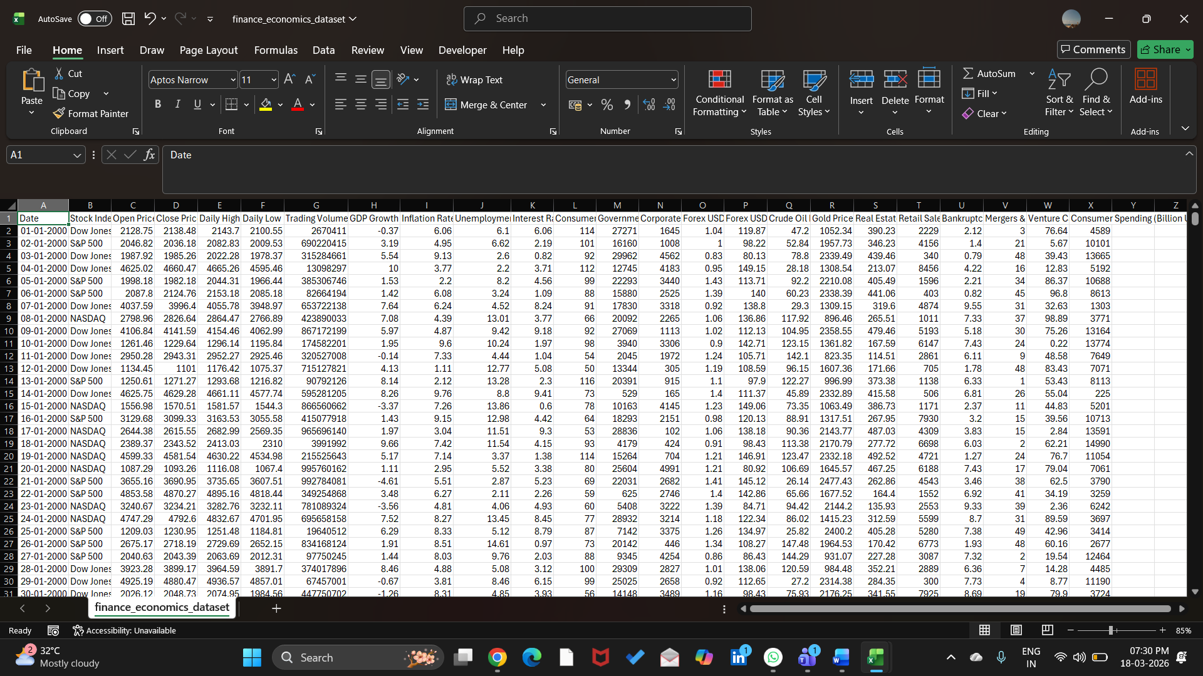
Figure 1: Screenshot of the raw (uncleaned) dataset

Figure 2: Screenshot of the cleaned dataset

4.2 Visualization / Output Results
The cleaned data was used to build interactive dashboards in Microsoft Power BI. Key outputs include:
- Dashboard 1: Market Performance & Volatility Analysis
This dashboard shows stock index trends (Dow Jones, NASDAQ, S&P 500), trading volume, and volatility patterns over time. It helps identify fluctuations and high-risk periods in financial markets.
- Dashboard 2: Economic Stress & Risk Analysis
This visual presents key macroeconomic indicators such as GDP growth, inflation rate, unemployment rate, and an overall economic stress index. It highlights periods of economic instability and risk levels.
- Dashboard 3: Investment Insights & Global Impact
This dashboard analyzes investment-related indicators such as crude oil prices, gold prices, forex rates, and their impact on financial markets. It helps in understanding global economic influence on investments.
- Additional Visuals:
  - KPI cards displaying risk level, volatility score, and key metrics
  - Area charts and line graphs for trend analysis
  - Pie charts for distribution insights
  - Slicers for interactive filtering by time and indicators
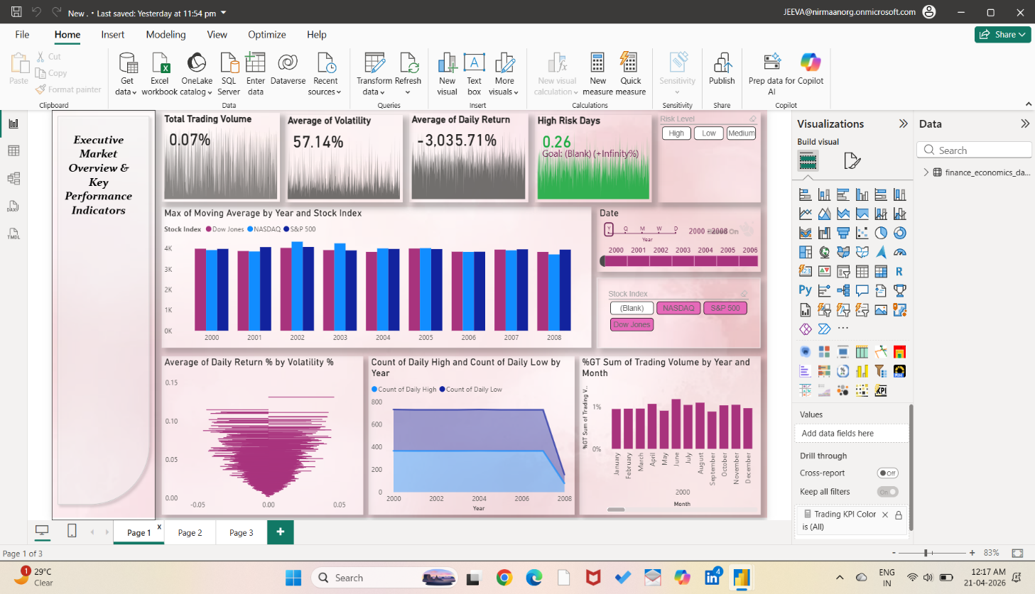

Screenshot of main dashboard

4.3 AI Tool Integration Results
- Tool Used:
AI tools such as Microsoft Copilot and ChatGPT were used.

- Prompts Used:
- “Summarize key insights from financial market trends including volatility and trading volume.”
- “Explain the relationship between GDP growth, inflation, and stock market performance.”
- “Generate a professional report summary for an economic stress dashboard.”
- Output Quality:
The AI-generated outputs were clear, structured, and contextually relevant. They helped convert complex numerical insights into easy-to-understand explanations suitable for reports and presentations.

- How it Enhanced the Project:
- Reduced time required for manual report writing
- Improved clarity and professionalism of insights
- Helped identify hidden patterns and relationships in the data
- Assisted in generating explanations for dashboards (useful for viva)
- Enabled faster analysis through prompt-based interaction.

CHAPTER 5
Discussion and Conclusion
5.1 Key Findings
- Key Finding 1:
During data preprocessing, approximately 10–15% of the records contained inconsistencies or missing values, and a small percentage of duplicate entries were identified. Cleaning these issues significantly improved the accuracy and reliability of the dashboard insights.
- Key Finding 2:
The financial dashboards clearly revealed periods of high market volatility, where fluctuations in indices like Dow Jones, NASDAQ, and S&P 500 aligned with changes in economic indicators such as inflation and unemployment.
- Key Finding 3:
A strong relationship was observed between macroeconomic factors (GDP growth, inflation) and market performance, indicating that economic stress directly impacts investment trends and risk levels.
- Key Finding 4:
The Economic Stress & Risk Dashboard helped identify high-risk periods, enabling better understanding of when markets are unstable.
- Key Finding 5:
AI tools like Microsoft Copilot and ChatGPT reduced the time required for generating summaries and explanations from hours to a few minutes, improving efficiency.
- Key Finding 6:
Interactive dashboards created using Microsoft Power BI made it easier to visualize complex datasets and derive actionable insights compared to traditional spreadsheet analysis.
5.2 Project Links
- GitHub Link of the Project: [https://github.com/JeevaThangaraj/StudentName-AI-Fellowship-Project.git]

5.3 Limitations
- The project is based on historical (static) datasets and does not include real-time data updates.
- The analysis is limited to descriptive insights and does not include advanced predictive models or forecasting techniques.
- Some AI features of Microsoft Copilot were limited due to accessibility constraints.
- The dataset used may not fully represent all real-world financial scenarios, which could affect generalization.
- External factors such as sudden economic crises or policy changes are not dynamically incorporated into the analysis.
5.4 Future Work
- Integrate real-time data sources using APIs or Power BI live connections for up-to-date analysis.
- Apply machine learning models (e.g., forecasting, trend prediction, anomaly detection) to enhance decision-making.
- Develop a web-based or mobile-friendly dashboard using tools like Power Apps for broader accessibility.
- Expand the dataset to include more global financial indicators and diverse data sources.
- Create a standardized prompt library for AI tools like ChatGPT and Copilot to improve consistency in insights generation.
- Incorporate advanced financial metrics such as portfolio optimization and risk-adjusted returns.
5.5 Conclusion
This project successfully addressed the challenge of analyzing complex financial and economic data by integrating Business Intelligence tools and AI-assisted techniques. The primary objective was to transform raw, unstructured datasets into meaningful insights through data cleaning, analysis, and visualization.
Using Microsoft Excel and Microsoft Power BI, interactive dashboards were developed to represent market performance, economic stress, and investment trends. The integration of AI tools such as Microsoft Copilot and ChatGPT enhanced the efficiency of analysis and report generation.
All the project objectives were successfully achieved, including data preprocessing, dashboard creation, and AI-assisted insight generation. The findings demonstrate that combining BI tools with AI can significantly improve decision-making by providing clear, data-driven insights.
Overall, this project adds value by showcasing a practical and scalable approach to financial data analysis. It also provided valuable hands-on experience in data analytics, visualization, and AI integration, making it highly relevant for future professional applications in finance and business intelligence.

REFERENCES
[1] Microsoft Corporation. Microsoft Excel Documentation. Available at: https://support.microsoft.com/en-us/excel
[2] Microsoft Corporation. Power BI Documentation. Available at: https://learn.microsoft.com/en-us/power-bi/
[3] Microsoft Corporation. Microsoft Copilot — AI-Powered Productivity. Available at: https://copilot.microsoft.com
[4] Edunet Foundation. AICW Fellowship Program Guidelines. 2026.

